Scenario 5: Blocking a User From Viewing the S3 Bucket Policy (Using Resource-Based Policy)
From the previous scenario (scenario 4),we could see that user-testuser has all read access to s3 bucket. This means testuser can:
- List s3 bucktes
- View bucket contents
- See the bucket policy ( because s3:GetBucketPolicy is allowed indirectly via AmazonS3ReadOnlyAccess policy)
Now I need hide bucket policy from testuser.
Using Resource-Based Policy (Bucket policy) with an explicit Deny
Step 1: under suchi account > go to s3 > select the bucket and go to the permissions.
Step 2: edit the bucket policy to deny bucketpolicy to testuser.
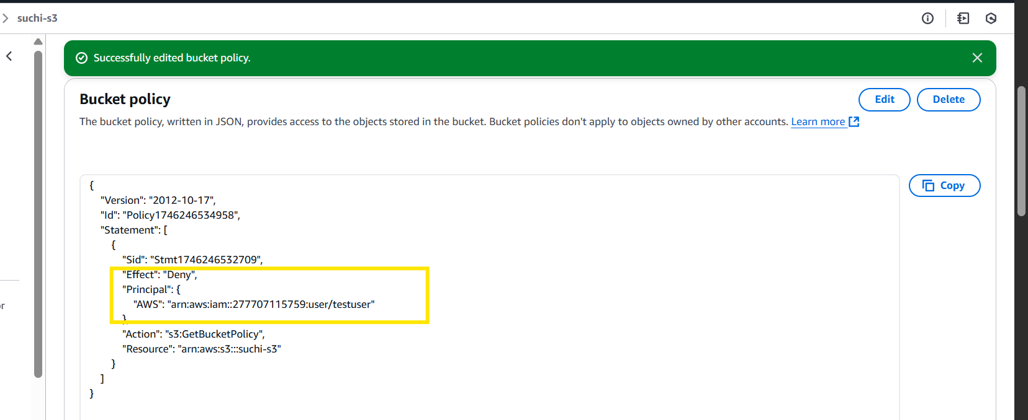
Step 3: validation - we could that even though user has all read access, since it is denied that resource base he can’t view the bucket policy.

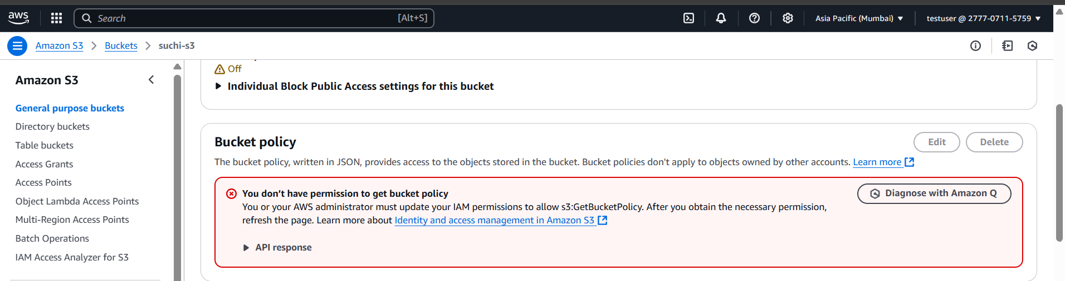
Note :
- Resource-based policies override IAM permissions
An explicit Deny in a bucket policy always wins — even if IAM grants access.
- IAM policy = “allow general S3 actions”
Bucket policy = “final authority on this bucket”
- Deny > Allow
This is the top rule in AWS authorization.
Summary
- testuser had read-only access to the S3 bucket, including visibility of the bucket policy
- We wanted to hide the bucket policy from them
- Added a resource-based Deny in the bucket policy
- Now testuser can still read objects but cannot view the bucket policy
- This demonstrates how SCP > Bucket Policy > IAM Policy in enforcement hierarchy
- Explicit Deny always overrides allow

